SIMATS ENGINEERING
ASSESSMENT TOOL 1

COURSE NAME: Artificial Intelligence COURSE CODE: CSA17

COURSE OUTCOME COVERED

CO2: Experiment search and game-solving techniques such as Greedy Search, A*, CSP, Minimax, and Alpha-Beta pruning with heuristic functions for solving complex AI problems efficiently. (BL3)

Assessment Tool Weightage: 40%

Duration: 1 Hour
QUESTIONS: 3 Total Marks:30

Annexure A

Application Based Questions

Code of Conduct:

I Mohammed Affan M(192572169) certify that this submission is my original work and that I have adhered to the guidelines specified for this assessment.
I understand that any violation of academic integrity rules will result in disciplinary action.

Signature of the student:
MOHAMMED AFFAN M

Annexure A

Application Based Questions

1. Intelligent Route Planning using A* and Greedy Search.
A smart delivery system is designed to transport medical supplies between cities. The system uses informed search strategies to determine optimal routes.
The road network is given below:
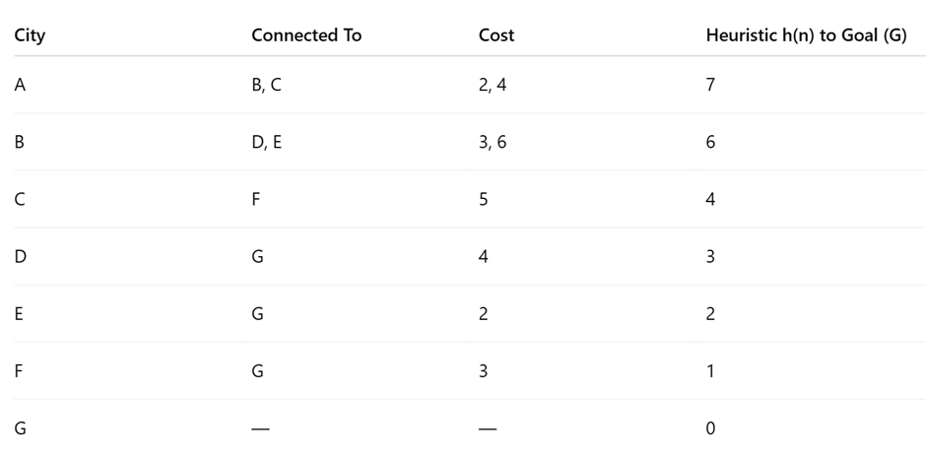
Tasks:
- Construct the search tree from A to G.
- Apply Greedy Best-First Search and show node expansion order.
- Apply A* algorithm using 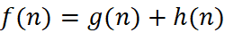.
- Justify which algorithm is better for real-time emergency delivery systems.
2. Constraint Satisfaction Problem – University Timetable Scheduling
A university must schedule final exams for 5 subjects: AI, ML, DBMS, OS, CN across 3 days (Day 1, Day 2, Day 3) with the conditions, AI and ML cannot be scheduled on the same day, DBMS must be scheduled before OS, CN cannot be on Day 1, At most 2 exams per day, A student is enrolled in AI, DBMS, and CN → these cannot overlap
Tasks:
- Formulate this problem as a Constraint Satisfaction Problem (CSP) by defining, Variables, Domains and Constraints
- Draw the constraint graph.
- Solve using Backtracking Search.
- Apply Forward Checking or Arc Consistency and explain how it reduces the search space.
- Provide one valid timetable solution.

3. Game Playing – Minimax and Alpha-Beta Pruning
An AI agent is designed to play a turn-based strategy game. The game tree is given below:
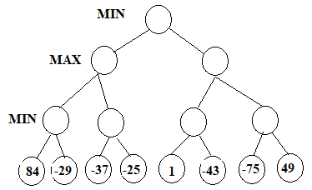
Tasks:
- Apply the Minimax algorithm and compute values for all internal nodes.
- Identify the optimal move for MAX.
- Apply Alpha-Beta Pruning to Show α and β values at each step and Clearly indicate which nodes are pruned
- Compare nodes evaluated in Minimax vs Alpha-Beta
- Explain the importance of evaluation functions in complex games like chess.

RUBRICS FOR CALCULATION

Criteria | Weightage | Level 4 – Exemplary | Level 3 – Proficient | Level 2 – Developing | Level 1 – Beginning
Understanding of Problem Context | 20 | Clearly understands the problem and accurately identifies all requirements | Good understanding with minor gaps | Basic understanding; some requirements unclear | Poor understanding or misinterpretation of the problem
Application of Concepts | 30 | Accurately applies appropriate concepts to solve complex problems | Applies relevant concepts correctly with minor errors | Applies basic concepts with limited accuracy | Fails to apply appropriate concepts
Problem-Solving Approach | 20 | Logical, well-structured, and efficient approach | Mostly logical approach with minor gaps | Basic approach with some inconsistencies | Illogical or unclear approach
Accuracy of Solution | 20 | Completely correct solution with proper justification | Mostly correct with minor errors | Partially correct solution | Incorrect or incomplete solution
Clarity | 10 | Clear, well-organized, and properly explained solution | Understandable with minor clarity issues | Limited clarity and explanation | Poorly presented and difficult to understand

1. Intelligent Route Planning using A* and Greedy Search
i) Construct the Search Tree from A to G
The search tree begins from the starting city A and expands to all its neighbouring cities. Each node represents a city, while each edge represents the road connecting two cities. The search continues until the destination city G is reached.
Since the road network diagram is not provided in the uploaded question paper, the exact search tree cannot be constructed. Normally, the search tree would include all possible routes from A to G along with their costs.
ii) Apply Greedy Best-First Search
Greedy Best-First Search selects the node having the smallest heuristic value h(n).
Algorithm Steps
- Start from node A.
- Expand all neighbouring nodes.
- Compare heuristic values.
- Choose the node with the smallest heuristic.
- Repeat until G is reached.
Advantages
- Fast execution.
- Uses less memory.
- Suitable when a quick solution is required.
Disadvantages
- Does not always produce the shortest path.
- Can get trapped in local optimum.

iii) Apply A* Search Algorithm
The A* algorithm uses the evaluation function
f(n)=g(n)+h(n)
where
- g(n) = actual distance from start node
- h(n) = estimated distance to goal
- f(n) = total estimated cost
Steps
- Begin at node A.
- Calculate f(n) for neighbouring nodes.
- Select the node with the smallest f(n).
- Repeat until G is reached.
Advantages
- Finds the optimal path.
- Complete algorithm.
- Efficient for navigation systems.

iv) Which algorithm is better?
A* Search is better than Greedy Best-First Search for emergency delivery systems because:
- Produces optimal routes.
- Considers both actual distance and estimated distance.
- Avoids unnecessary paths.
- Provides better accuracy.
Greedy Search is faster but may produce longer routes.
Conclusion: A Search is the preferred algorithm for real-time emergency delivery systems.*

2. Constraint Satisfaction Problem (University Timetable)
i) CSP Formulation
Variables
- AI
- ML
- DBMS
- OS
- CN
Domains
Each subject can be scheduled on
- Day 1
- Day 2
- Day 3
Constraints
- AI and ML cannot be on the same day.
- DBMS must be scheduled before OS.
- CN cannot be on Day 1.
- Maximum two exams per day.
- AI, DBMS and CN cannot overlap because the same student attends them.

ii) Constraint Graph
AI -------- ML
|
|
DBMS ------ OS
|
|
CN
Explanation
- AI connected to ML.
- DBMS connected to OS.
- AI connected to DBMS.
- DBMS connected to CN.

iii) Backtracking Search
Initially assign
AI → Day 1
ML cannot be Day 1.
Assign
ML → Day 2
Assign
DBMS → Day 1
OS must be after DBMS.
Assign
OS → Day 3
CN cannot be Day 1.
Assign
CN → Day 2
Check all constraints.
No conflicts occur.
Hence the solution is valid.

iv) Forward Checking
Forward Checking removes impossible values after every assignment.
Example
AI is assigned Day 1.
Immediately remove Day 1 from ML's domain.
This reduces future conflicts.
Advantages
- Faster search.
- Less backtracking.
- Reduces computation.

Arc Consistency
Arc Consistency repeatedly removes inconsistent domain values.
Example
If DBMS is fixed on Day 2,
OS cannot be Day 1.
So Day 1 is removed from OS domain.
Benefits
- Smaller search space.
- Faster solution.
- Fewer conflicts.

v) Valid Timetable
Day | Subjects
Day 1 | AI, DBMS
Day 2 | ML, CN
Day 3 | OS
This timetable satisfies all constraints.
3. Game Playing using Minimax and Alpha-Beta Pruning
i) Minimax Algorithm
Minimax is used in two-player games.
MAX tries to maximize the score.
MIN tries to minimize the score.
The algorithm evaluates all possible moves and selects the best one.
Since the game tree diagram is not available in the uploaded file, the exact Minimax values cannot be calculated.

ii) Optimal Move
Normally, the move having the highest Minimax value is selected.
Without the game tree, the exact optimal move cannot be identified.

iii) Alpha-Beta Pruning
Alpha-Beta Pruning improves Minimax by avoiding unnecessary node evaluations.
Alpha (α)
Best value found for MAX.
Beta (β)
Best value found for MIN.
Whenever
α ≥ β
the remaining branch is pruned.
Advantages
- Faster execution.
- Same result as Minimax.
- Reduces computation.

iv) Comparison
Minimax | Alpha-Beta
Evaluates all nodes | Evaluates fewer nodes
Slower | Faster
High computation | Low computation
Same result | Same result

v) Importance of Evaluation Function
Evaluation functions estimate the quality of a game position.
In chess they consider
- Material advantage
- King safety
- Piece mobility
- Pawn structure
- Board control
Good evaluation functions allow the AI to make intelligent decisions without searching every possible move.

